NPGO RN Peer Review Preparation Tool
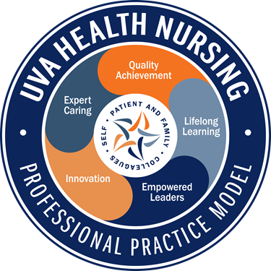
Use this tool to prepare for and take notes during your peer review discussion.

- To prepare for the peer review dialogue, begin with reflecting on yourself. Focus on the following two questions for each Professional Practice Model category:
- What are your strengths?
- How would you like to grow/improve?

- During your peer review dialogue, share your self-reflections. Then, invite your peer to add their feedback and ideas to what you have shared.

- When you document the peer review about your colleague following your discussion, use the responses shared by your peer about themselves and what you discussed to help inform what to write in each category, responding to the two questions.

Relationship Based Care: Self & Colleagues reflects the influence of the nurse’s relationship with self, colleagues and patient/family on the patient experience.

Provide specific examples / strengths in this category and ideas/feedback for growth/further development.
Examples and comments:

Relationship Based Care: Patient & Families reflects the influence of the nurse’s relationship with self, colleagues and patient/family on the patient experience.

Provide specific examples / strengths in this category and ideas/feedback for growth/further development.
Examples and comments:

Expert Caring encompasses clinical assessment, planning, prioritizing, coordinating and implementation of care.

Provide specific examples / strengths in this category and ideas/feedback for growth/further development.
Examples and comments:

Empowered Leaders demonstrate knowledge of and actively participate in professional governance.

Provide specific examples / strengths in this category and ideas/feedback for growth/further development.
Examples and comments:

Quality Achievement includes adherence to clinical documentation guidelines, comprehension of outcomes data, engagement in performance improvement activities and commitment to standard work.

Provide specific examples / strengths in this category and ideas/feedback for growth/further development.
Examples and comments:

Lifelong learning encompasses professional development through formal education, professional certification, internal and external learning opportunities and recognizes the value of external professional organizations. Supports onboarding of new team members and precepts as applicable.

Provide specific examples / strengths in this category and ideas/feedback for growth/further development.
Examples and comments:

Innovation is demonstrated by application of technologies that support patient care, actively seeking to implement evidence based practice and new knowledge generated by nursing research.

Provide specific examples / strengths in this category and ideas/feedback for growth/further development.
Examples and comments:

ASPIRE: if comments above do not address all ASPIRE values, please use the box below to provide specific examples / strengths in this category and ideas/feedback for growth/further development.

Updated: 10.2023

