Day 2 Agenda
Welcome to UVA!
AM Sessions (Zoom)
Time | Content | Facilitators/Instructors
0745-0800 | Zoom Login Registration | NPDS
0800-0815 | Welcome and Review of Agenda | NPDS
0815-0900 | Infection Prevention & Control | Jim Hovanec/Heather Cosner
0900-0930 | Respiratory Fit Testing | Jimmy Fry
0930-0945 | Break
0945-1000 | FEAP | Mary Sherman
1000-1015 | Overview of KnowledgeLink Resources | NPDS
1015-1030 | Evidence-Based Practice | Katie Platz/Tracye Proffitt
1030-1050 | Workplace Violence Prevention | Emily Shabani/Jessica Alford
1050-1120 | Epic Overview | Lori Mitchell/Irene Bouck
1120-1130 | Virtual Tour of the Nursing Center for Excellence Website | NPDS
1130-1145    Scan to complete the post class survey | Day 3 Instructions/Closing Remarks/Survey/Q&A | NPDS
1145-1230 | Lunch
PM Sessions (Workday Modules)
Time | Content | Assigned By
1230-1630 | Epic Assessment (Epic Test Out Eligibility: Nurses – RN Clinician 2 or higher/LPN with previous Epic experience) | Epic Group
1230-1630 | POCT: Color Blindness Test (all staff who perform POCT) | NPDS
1230-1630 | POCT: Glucometer Initial Training | NPDS
1230-1630 | Pyxis Med Station ES (All Nurses - Ambulatory and Inpatient, Including LPN and CNS) | NPDS
1230-1630 | All appropriate Epic Digital modules for the staff member’s job description | Epic Group
1230-1630 | Introduction to PolicyTech | NPDS
1230-1630 | Suicide Prevention UVA Medical Center | NPDS
Day 3 Facilitated by Nursing Professional Development Services (NPDS)
Attendees: CNA, PCT, LPN, RN (including Travelers), ED Tech, CV Tech, Mental Health Tech, Endoscopy Tech, CMA, Athletic Trainer, Paramedic, Ambulatory RNCC, Ophthalmology Assistant, PREOP/SAS, PACU, Extended Stay RN (Main, OPSC, OCIR), Transfers: ambulatory to inpatient, inpatient to ambulatory, or to higher level of care, (NICU RNs attend on unit)

Excludes: Patient companions, travelers converting to permanent staff, team members
re-hired within last 12 months, OP dialysis, OR (Main, OPSC, OCIR), Surgical Center Riverside
Specialty Regions: | Location | Start Time: | Content:
Inpatient | Northridge Nursing Professional Development (Northridge Medical Park):  Park at the Korean Community Church 645 Kirtley Lane  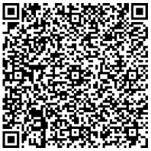  Scan for Google Maps driving directions to 645 Kirtley Lane  Walking Directions from Parking Lot to rear entrance of the 2965 building. Northridge Nursing Professional Development.  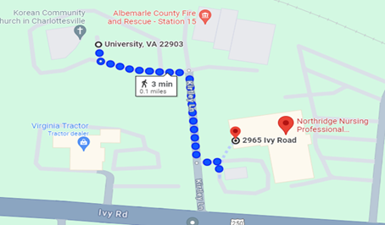 | Inpatient Registration: 0730-0745    https://www.offstreet.io/events/J85GTD6O  Scan to complete your parking permit for Northridge days only. This only needs done once and will work for ALL Northridge days. | Minimal lift  A&P pumps & IOP  PCA Pumps  Nomograms  Falls  Restraints  HAPI
Ambulatory |  | Ambulatory Registration: 0800-0825  https://www.offstreet.io/events/J85GTD6O  Scan to complete your parking permit for Northridge days only. This only needs done once and will work for ALL Northridge days. | Ambulatory:  Intake vs. Triage  Rooming  Orders  MAR/Immunization  Screenings  Charge Capture  Nasal/Oral Swabbing  Minimal lift
Day 4-5 Epic Training (Timing and day varies by role)
Epic training and modules (location TBD by manager or Epic). Refer to your email from Epic Clinical Training (sent to UVA email 2 days prior to class).

Note: Respiratory Fit testing for travelers Thursday 1300-1530 with Employee Health (last check-in time is at 1500)
Week 2 Agenda
See the table below to determine what days you are supposed to attend
Northridge Nursing Professional Development Skills Days
Day 6 | Days 7 & 8
UAPs (CNA, PCT, EMT, ED Tech, Endoscopy Tech), All ambulatory (PCT, LPN, MA, RN, Athletic Trainer, Ophthalmology Assistant, Infusion), Experienced RN (Clin 2 and higher), Internationally Educated Nurses, Paramedic | Clin 1, RNs changing practice areas (for example OR to inpatient, ambulatory to inpatient)
Excluded from Northridge: External & internal travelers, travelers converting to permanent staff, team members re-hired within the last 12 months, Patient Safety Companions, OP Dialysis, OR, CV Techs, Mental Health Techs, Earn While You Learn, SCR (Riverside) PREOP/OR/PACU.
Northridge Nursing Professional Development Parking Logistics
Arrival Time | Location | Northridge Parking
0800 | Northridge Nursing Professional Development (Northridge Medical Park): Park at the Korean Community Church 645 Kirtley Lane  Scan for Google Maps driving directions to 645 Kirtley Lane  Walking Directions from Parking Lot to rear entrance of the 2965 building. Northridge Nursing Professional Development. | https://www.offstreet.io/events/J85GTD6O  Scan to complete your parking permit for Northridge days only.

